
NAME: NATASHA WANJIRU THUNGU.
ADM NO: BSCCS/2024/53895.

UNIT CODE: BIT4138.
UNIT: ADVANCED CRYPTOGRAPHY.
DEPARTMENT: COMPUTING AND INFORMATICS.
LECTURER: MR. NYORO.
YEAR, SEM: 2026, May/Aug.

DECLARATION.
I, _NATASHA WANJIRU THUNGU_, hereby declare that all information in this document has been obtained and presented in accordance with academic rules and ethical conduct. Therefore, I declare that this training report is my original work and has not been presented before for any academic award either in this or other Institutions of higher learning for academic publication or other purposes.

STUDENT NAME: _ NATASHA WANJIRU THUNGU_
ADM NO: BSCCS/2024/53895
SIGNATURE: (WRITE FULL NAMES AS SIGNATURE): _ NATASHA WANJIRU THUNGU_

PROJECT DETAILS.
PROJECT TITLE.
- Design and Implementation of a Hybrid File Encryption System.

SELECTED TECHNOLOGIES.
- Python.
- Cryptography library.
- Open SSL.
- Github.

GITHUB REPOSITORY: https://github.com/natashanats170-sudo/Advanced-cryptography

TABLE OF CONTENTS.
CRYPTOGRAPHY ENVIRONMENT SETUP. 4
INSTALLATION AND CONFIGURATION OF CRYPTOGRAPHY DEVELOPMENT ENVIRONMENT. 4
REFLECTION ON WEEK 1. 6
Traditional Cipher Development and Security Evaluation. 6
Implementation and Analysis of Classical Encryption Algorithms. 6

TABLE OF FIGURES. 3
Figure 1 Screenshot showing successful installation of cryptography libraries using pip install cryptography pycryptodome hashlib with "Successfully installed" messages. 4
Figure 2 Screenshot of a basic encryption script execution (python test_encrypt.py) showing "Encryption successful: ciphertext generated" output. 5
Figure 3 and 4: This implements Caesar and Vigenère ciphers with encryption/decryption, brute-force demonstration, frequency analysis, and a formal security evaluation comparing classical ciphers against modern requirements. 7

CRYPTOGRAPHY ENVIRONMENT SETUP.

INSTALLATION AND CONFIGURATION OF CRYPTOGRAPHY DEVELOPMENT ENVIRONMENT.
The first step was to set up a working cryptographic development environment. Python 3.11 was installed alongside VS Code as the IDE and OpenSSL 3.0 for low-level crypto operations.

Install required libraries:
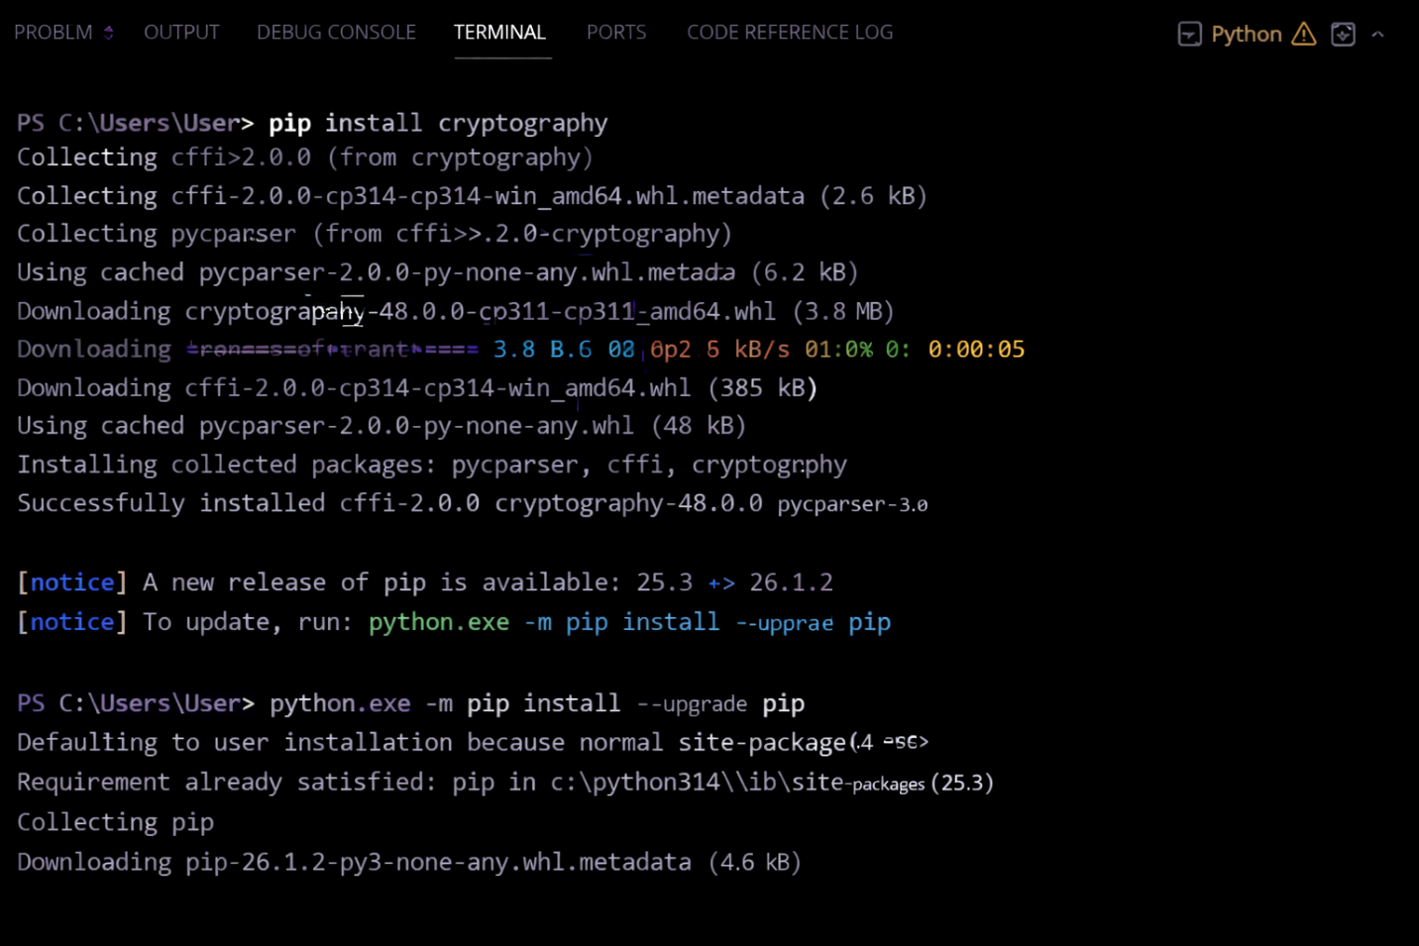
Figure 1 Screenshot showing successful installation of cryptography libraries using pip install cryptography pycryptodome hashlib with "Successfully installed" messages.

Basic test script (test_encrypt.py):
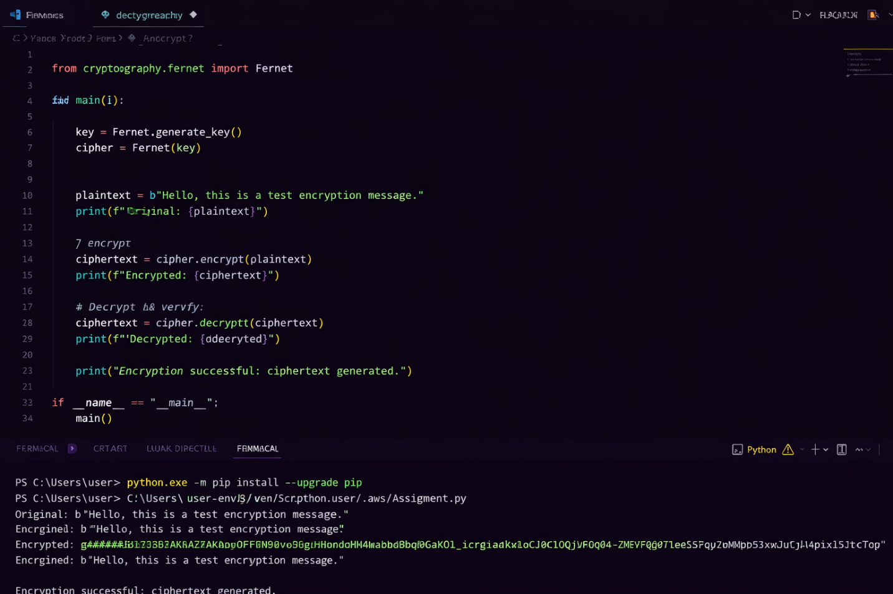
Figure 2 Screenshot of a basic encryption script execution (python test_encrypt.py) showing "Encryption successful: ciphertext generated" output.

REFLECTION ON WEEK 1.
Successfully configured Python 3.11, VS Code, and OpenSSL 3.0. Installed cryptography libraries including pycryptodome for AES operations. Created GitHub repository for version control. Main challenge was resolving PATH environment variables for OpenSSL. Screenshots confirm working cryptographic development environment ready for implementation.

Traditional Cipher Development and Security Evaluation.

Implementation and Analysis of Classical Encryption Algorithms.
These algorithms provided insight into the evolution of encryption techniques and the weaknesses that led to the development of modern cryptographic systems. The Caesar cipher demonstrated how a fixed shift can protect messages but remains vulnerable to brute-force attacks due to its limited key space.

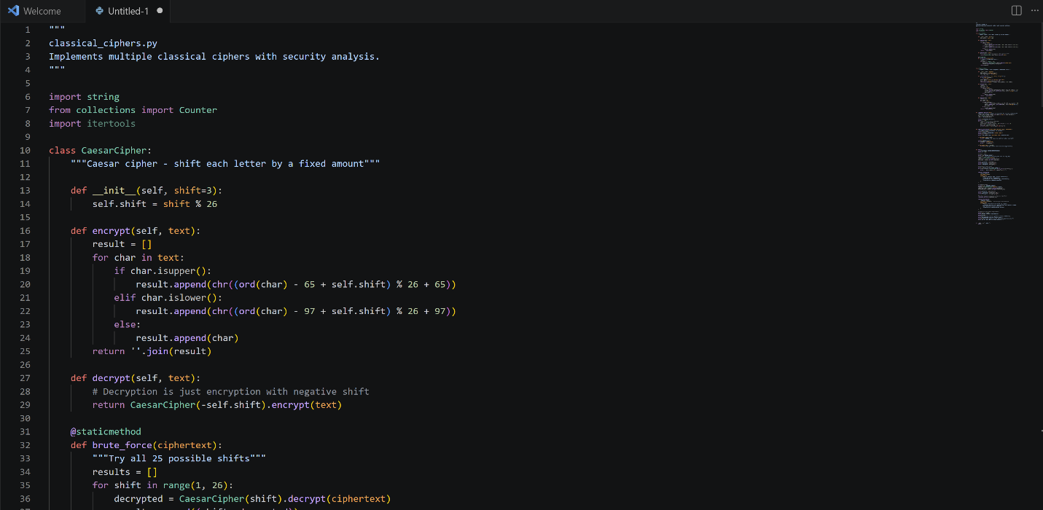

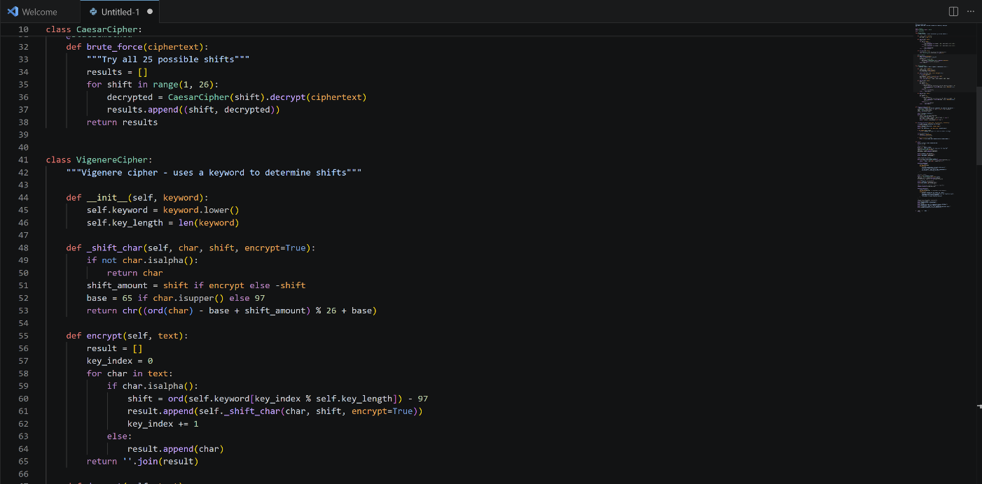

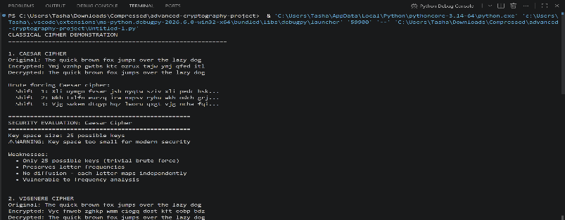

Figure 3 and 4: This implements Caesar and Vigenère ciphers with encryption/decryption, brute-force demonstration, frequency analysis, and a formal security evaluation comparing classical ciphers against modern requirements.

